Refer arithmetic.h

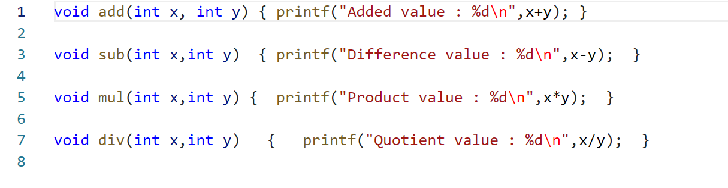

Refer including_arithmetic_header_file.c

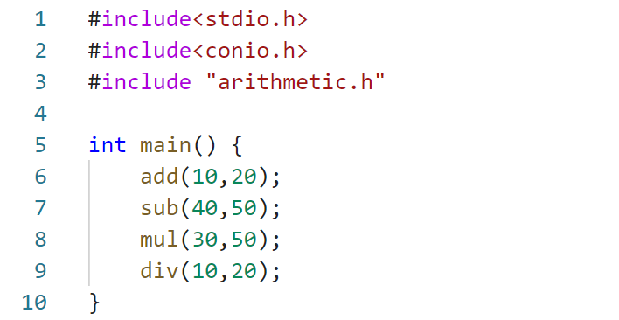

Output

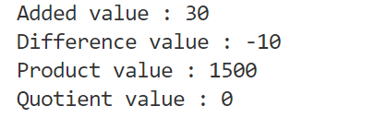

# Macros

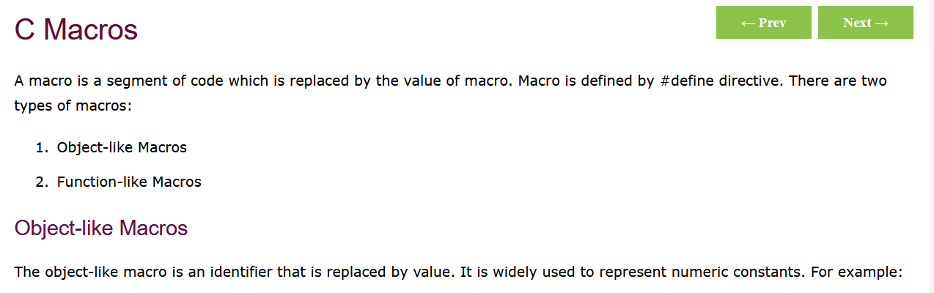

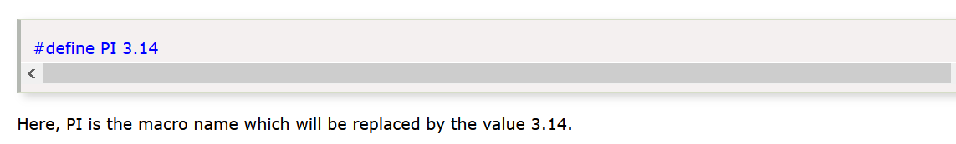

## Refer macros_1.c

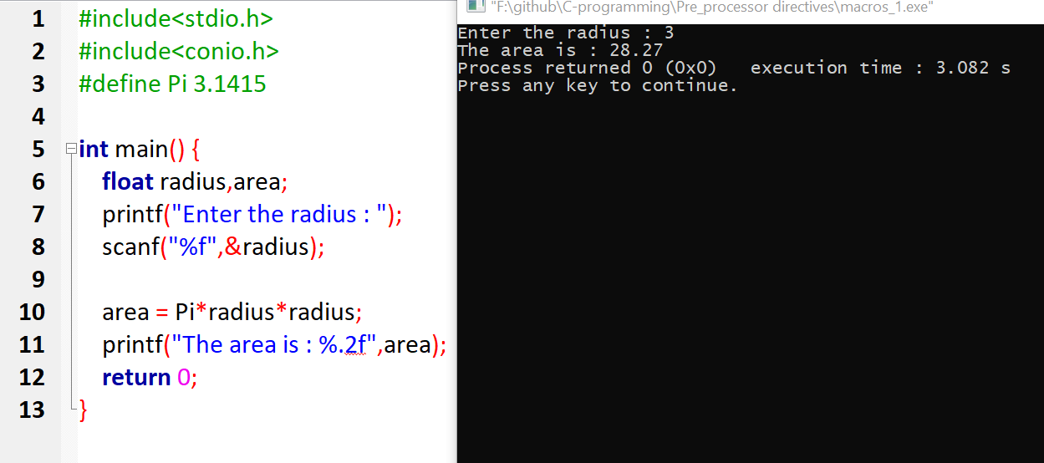

## Refer macros_2.c

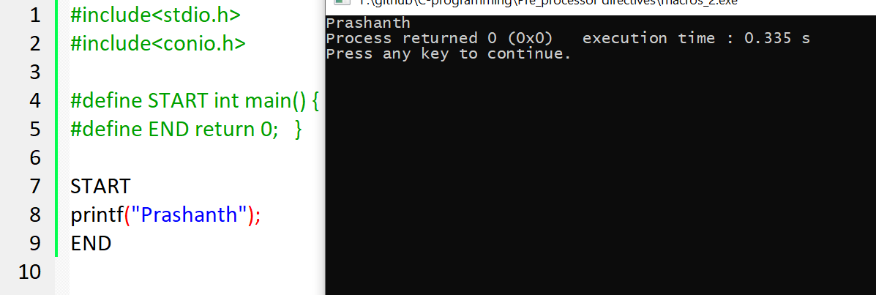

## Refer macros_3.c

